Project Design Phase-II
Data Flow Diagram & User Stories
Date | 16 February 2026
Team ID | LTVIP2026TMIDS85401
Project Name | Strategic Product Placement Analysis
Maximum Marks | 4 Marks

Data Flow Diagrams:
A Data Flow Diagram (DFD) is a traditional visual representation of the information flows within a system. A neat and clear DFD can depict the right amount of the system requirement graphically. It shows how data enters and leaves the system, what changes the information, and where data is stored.

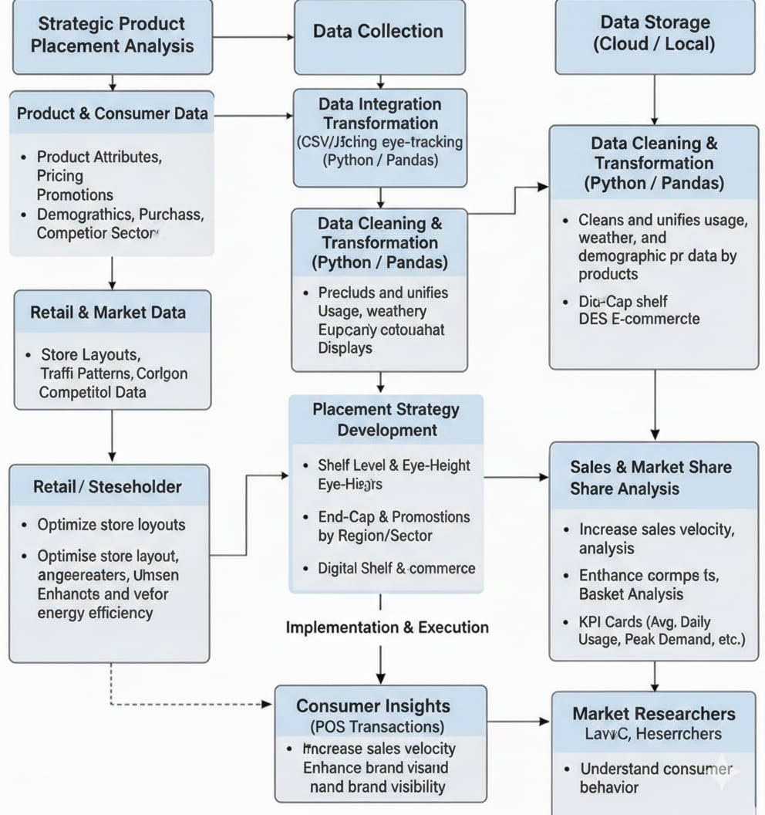
Understand Consumer behavior

User Stories:
Use the below template to list all the user stories for the product.
User Type | Functional Requirement (Epic) | User Story Number | User Story / Task | Acceptance Criteria | Priority | Release
Merchandising Analyst | Data Access & Integration | USN-1 | As a user, I can import retail sales and product placement data from CSV/Excel files or POS systems | Data loads successfully and is available for placement analysis | High | Sprint-1
Data Analyst | Data Cleaning & Preparation | USN-2 | As a user, I can clean and standardize product categories, store locations, and placement zones | Dataset is structured, consistent, and free from duplicates or missing placement labels | High | Sprint-1
Retail Manager | Dashboard Overview | USN-3 | As a user, I can view total sales, revenue, profit, and key placement KPIs | KPI cards display totals, growth %, and top-performing placement zones | High | Sprint-1
Category Manager | Placement Zone Analysis | USN-4 | As a user, I can compare product performance by shelf position (eye-level, end-cap, checkout, aisle) | Placement-wise visualizations update accurately and reflect correct sales contribution | High | Sprint-1
Regional Manager | Store & Regional Analysis | USN-5 | As a user, I can compare product placement performance across stores and regions | Store-wise and region-wise charts reflect accurate comparative data | High | Sprint-1
Marketing Analyst | Time-Based Trends | USN-6 | As a user, I can analyze monthly, quarterly, and seasonal sales trends by placement | Trend charts display correct time-based variations and seasonal impact | High | Sprint-1
Operations Executive | Filters & Interaction | USN-7 | As a user, I can filter data by store, category, time period, and placement zone | Dashboard updates dynamically based on selected filters | High | Sprint-2
Sales Strategist | Performance Insights | USN-8 | As a user, I can identify underperforming and high-performing placement zones | High- and low-performing zones are clearly highlighted using visual indicators | Medium | Sprint-2
Senior Executive | Story & Reporting | USN-9 | As a user, I can view story-driven insights for management presentations | Dashboard story view presents key insights with captions and summary analysis | Medium | Sprint-2
System Administrator | Dashboard Publishing & Sharing | USN-10 | As an admin, I can publish dashboards to Tableau Server/Power BI Service for stakeholder access | Dashboard is securely accessible with appropriate role-based permissions | Medium | Sprint-2

